A Message from the Principal
The earlier sunsets and the trees bursting with color remind us that summer is over and fall is here. I hope your family has settled into the routines of school. There are many ways for families to be involved at the Roosevelt which are detailed in this newsletter. Parents as Partners will be the name of a series of information sessions throughout the year, when parents can learn about a specific topic and meet other parents. The first one will be focused on good nutrition. Won’t you join us?

FDR Walk4Kids Walkathon
The 8th Annual Walk4kids Walkathon will take place on October 31st during school hours. The event is a fun way for us to raise funds to support enrichment activities such as afterschool programs, technology and grade-specific initiatives. In the past we have raised between $8,000 - $12,000. The walk will take place in the morning at the Upper Campus and in the afternoon at the Lower Campus. Students can dress up according to classroom specific guidelines. This year, 25% of the funds raised by each grade will be available for that grade to identify specific activities. Students and families are asked to raise funds by getting sponsorships from family, friends, neighborhoods and local businesses. Pledge sheets and more information will be going home this week. If you have any questions you can contact Lynda-Lee Sheridan or the parent volunteer coordinating the event, Marie Herb, mherb@tacinc.org.

Mixed Bag Fundraiser
This is the last week to place an order for the Mixed Bags Fundraiser. These high quality bags and home accessories were well received last spring. The deadline to place orders is October 8th, and they can be sent into school with your child or placed online at www.mixedbagdesigns.com/?fundraiserid=315000 If you have questions contact martinaryan19@gmail.com.
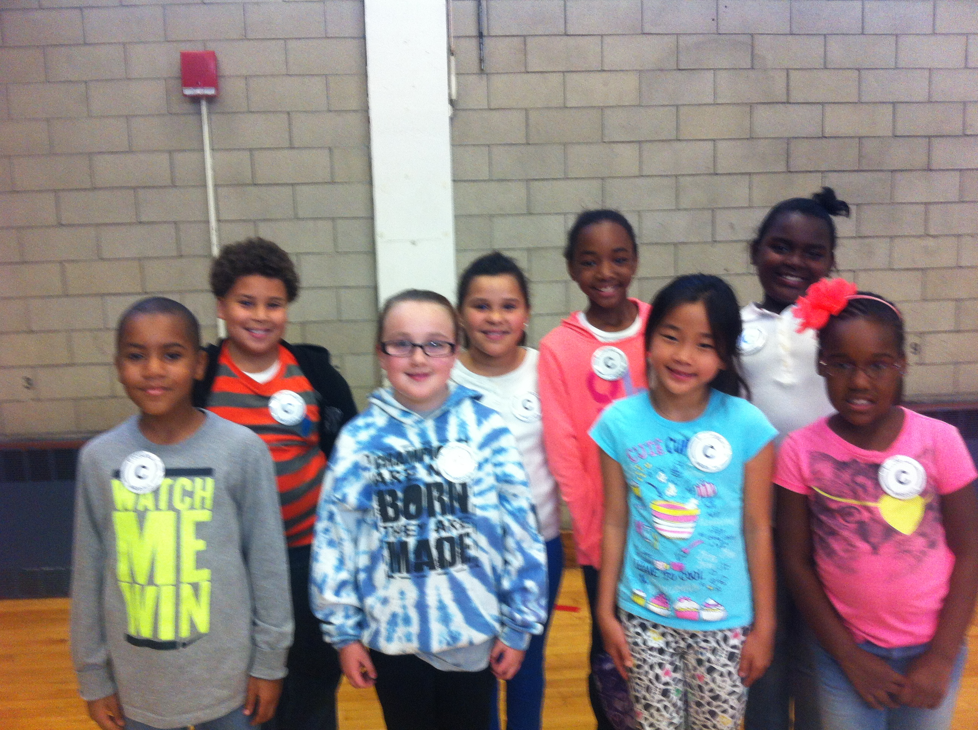

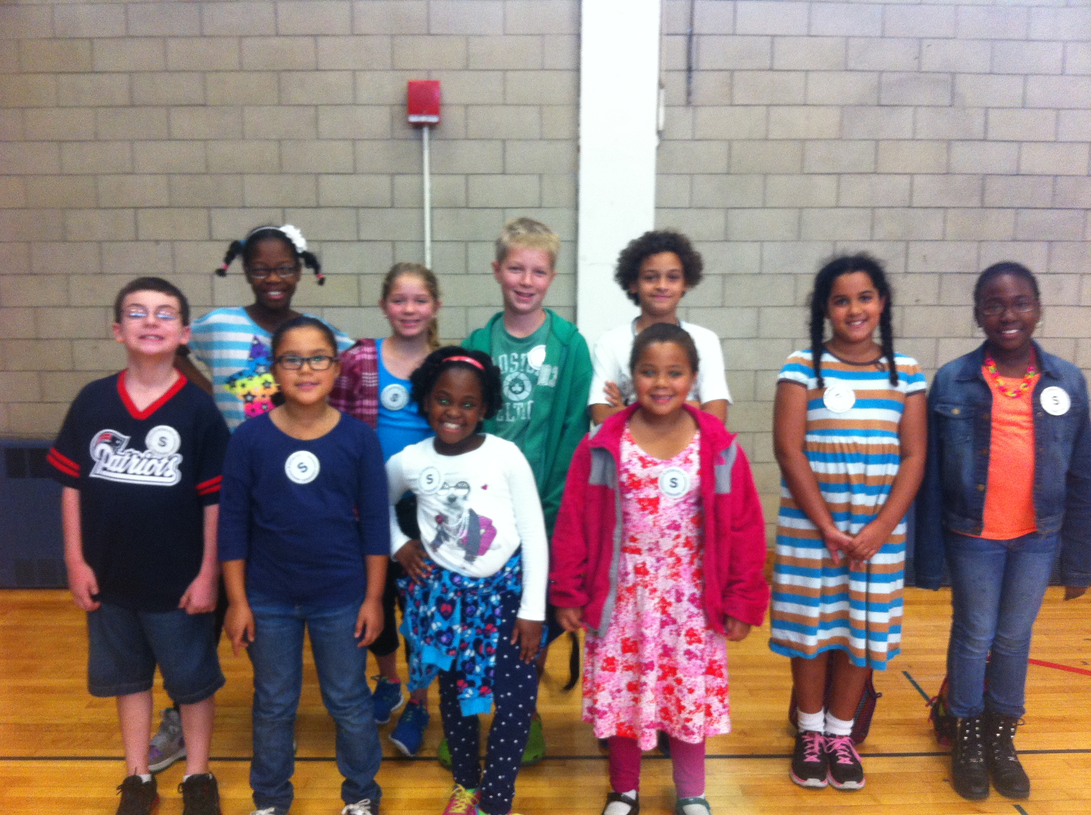
“Responsibility” Community Celebration
Grade | Room | Core Value  Award | Scholar  Award
2 | 104 | Zhira Watkins | Arianna Bellamy
 | 103 | Immanuel Kelly | Isabella Campbells
3 | 102 | Christine Hur | Chris Botteri
 | 101 | LaDiamond Horner | Jackie Alicia
4 | 204 | Alanis Tejeda | Raina Sumpter
 | 203 | Kayla Baptiste | Grace Carley
5 | 202 | Gianna Farrell | Derek Paulino  Sarah Joseph
 | 201 | Anthony Montes | Jack and Natalie Trapnick
K2 Happenings!
The K2 team is finishing up our unit on Community. The students had a great time interviewing members of our school community. They found out more about Ms. Olga( cafeteria manager), Mr. Richie(the custodian), Ms. Carline(the school nurse), and Mrs. Ryan(school secretary). The K2 Team also went apple picking at Honey Pot Hill. They had a wonderful time picking apples, choosing a pumpkin, going on a hayride and looking at the farm animals. We would like to thank our wonderful chaperones for all their help.
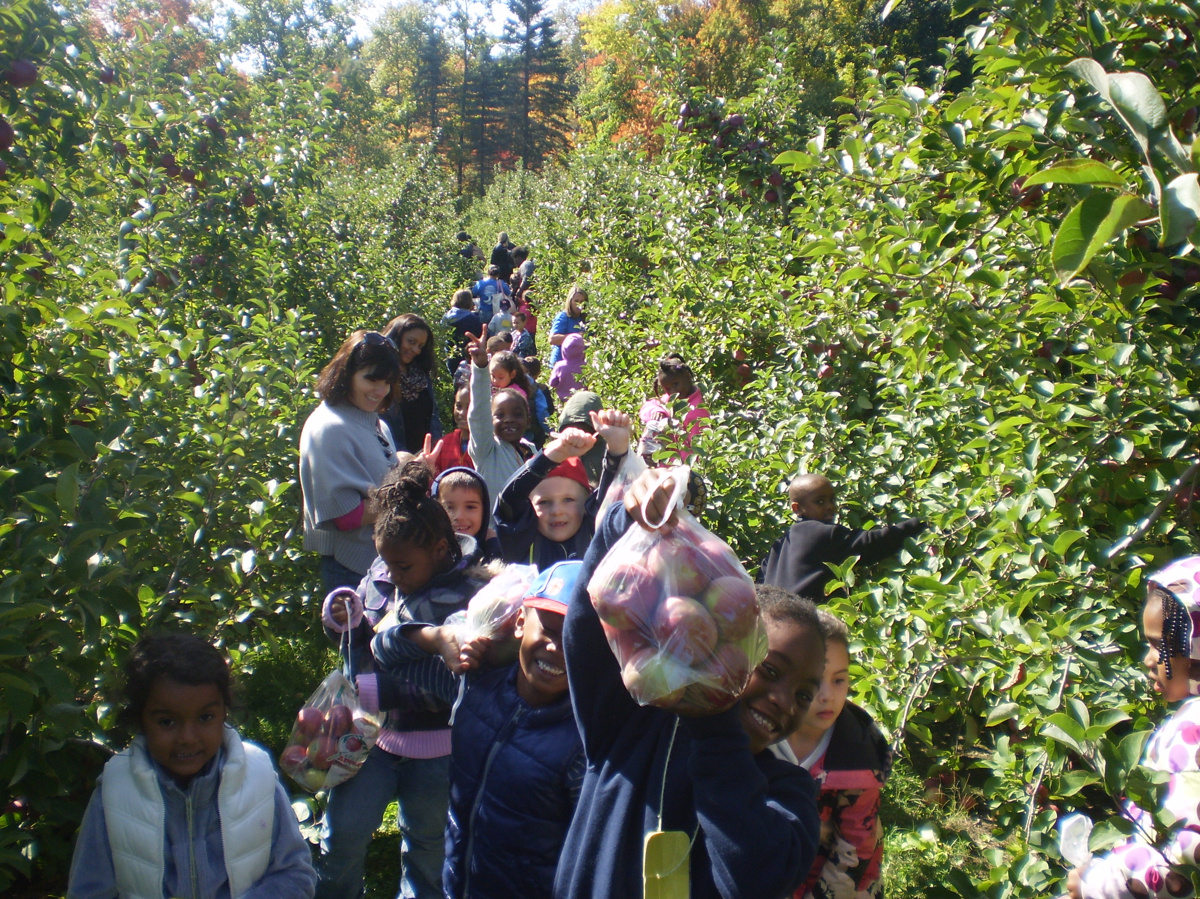

Community Meeting: Uniforms
The School Site Council has been discussing a possible uniform policy for school year 2015-2016. We surveyed families last Spring and new families in September. We will be having a community meeting on Wednesday, October 22nd at 6pm to share the data we have collected and discuss questions and concerns.
We encourage all families to attend!

Nutrition Information Session
for Parents
Please mark your calendars and plan to join others at a "Parents as Partners" night, on October 15th from 4-5PM. Our favorite nutritionist will share information about the nutrition topics being discussed in the K1, K2 and Grade 1 classrooms in the coming weeks.
Greetings from the 6th grade!
The 6th grade has been off to a great start and everyone has made a smooth transition into the ways of the middle school.
In ELA, the students are reading The Watsons Go to Birmingham and expanding their knowledge of the civil rights movement. In Math, students just completed their first unit about ratios and rates. They are now spending some significant time completing a skills assessment using the IXL website we have written home about. Please take a moment and have your child show you how it works and encourage them to use it to practice often. In Ancient Civilizations, 6A just completed a unit on early humans or hominids and are just beginning a new chapter. 6B is learning all about digestion in science and many will be attending an upcoming field trip to Harvard Medical for a science presentation called Explorations. Also coming up, the whole 6th grade will be taking a trip to Google Headquarters and getting an inside tour into the world of technology! Very exciting! All this and much, much more…. STAY TUNED!!

SPC Meeting
The first SPC Meeting will be held Wednesday September 24th at 6:15 in the Upper Campus library. Please join us to learn about all the ways you can become involved in the life of the school.

Grade 3 Successes!
Congratulation to grade 3 students!
This year students in Grade 3 are completing their nightly homework on-line. They complete Vocabulary/Spelling, Math & Reading as they prepare for learning in the 21st Century.

MBTA Update
The MBTA has changed the schedule of the 24 bus to accommodate our middle school students. The bus will stop infront of our school @ 2:20pm or 2:40pm. Please remind students they should take the bus home right after they leave our building.
A Special Visit to the Roosevelt
Last Friday the Roosevelt was honored to welcome the Secretary of Education for the state of Massachusetts, Matt Malone. He was joined by City Councilor Tim McCarthy, and Assistant Superintendent Al Taylor. Grade 8 students Eve Aridou and Jaelen Lee escorted him around the Upper Campus and Layla Powers, Jayden Gonsalves and Sonja Martin, escorted him around Lower Campus. Mr. Malone, and Mr. McCarthy stopped to talk to teachers and students and engaged in the lessons being taught. They appreciated the strong feeling of teaching and learning at the Roosevelt and commented on the beautiful artwork everywhere. Mr. Malone told us “This is the BEST Boston Public School I have visited”!

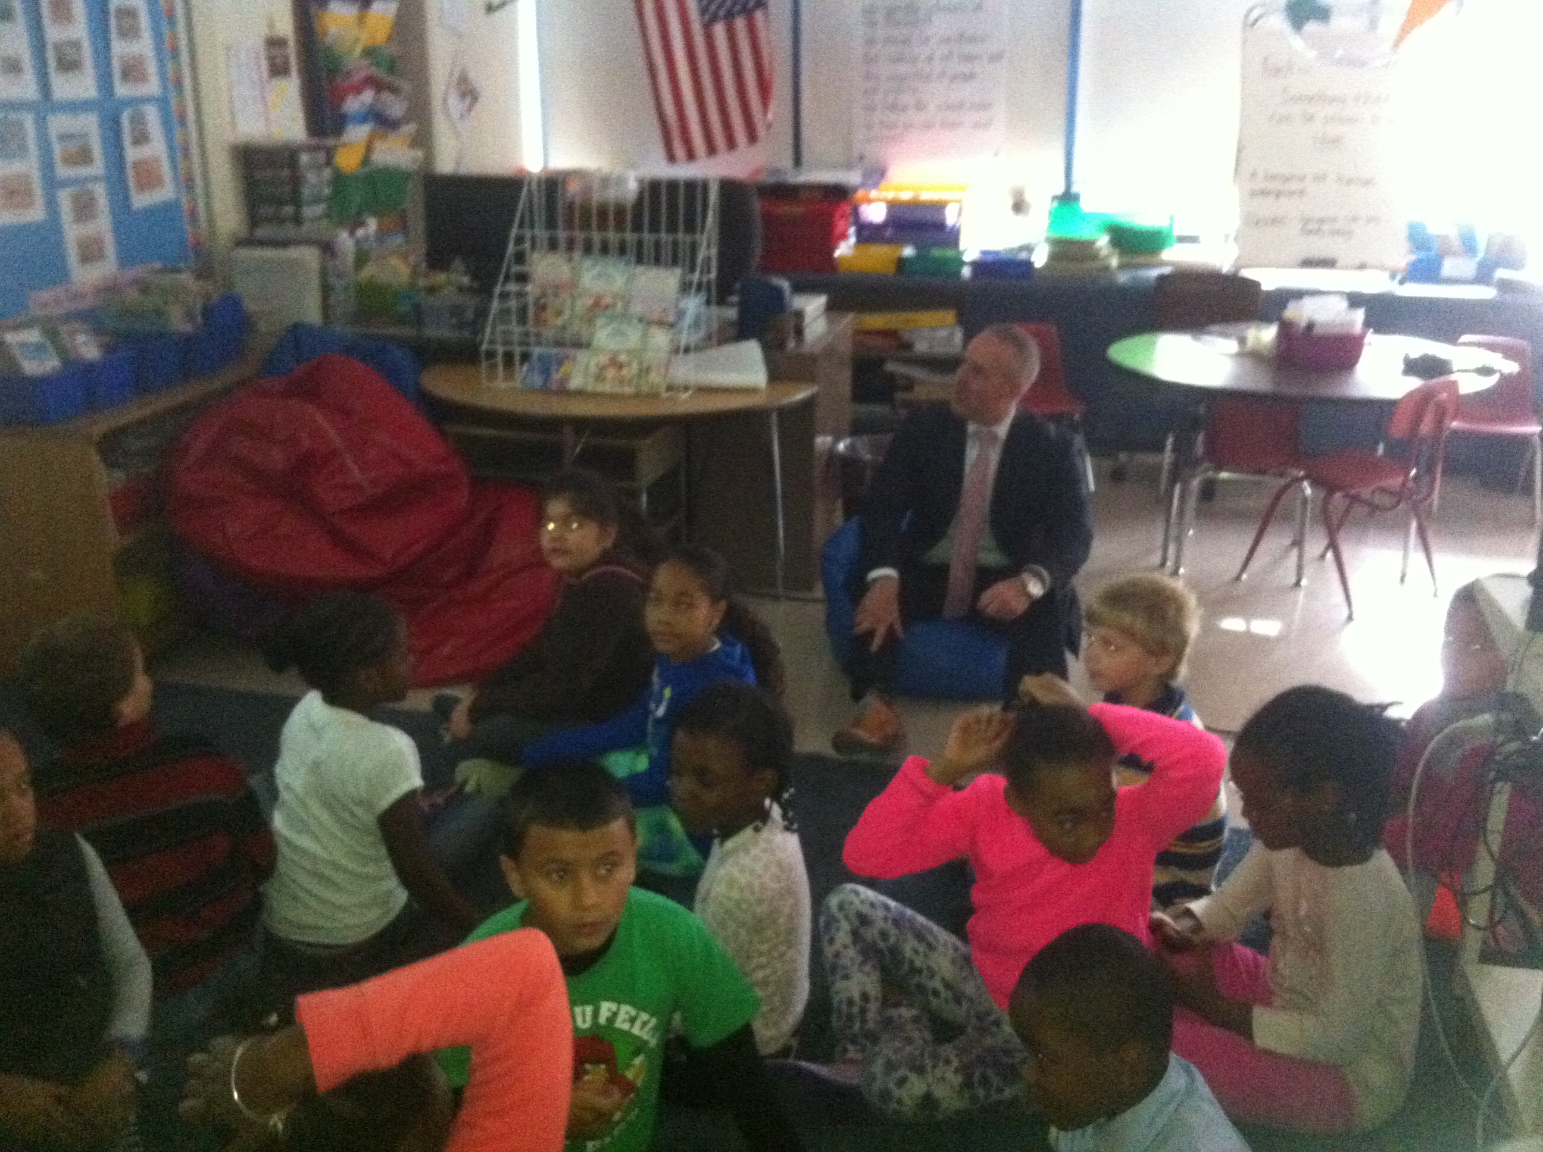
Box Tops for Education,
Labels for Education
Recycle old ink cartridges
Stop and Shop Rewards Card
These are all ways that you can easily support the Roosevelt School. Please send in Campbell Soup or Pepperidge Farm Labels for Education in addition to the small Box Tops for Education that you see on many food and paper products. Rather than throwing these items away, please send them into school and we can turn it into $$! Thanks to the parent volunteers who help with this effort.

Also don’t forget to register your Stop and Shop card: log on to www.stopandshop.com/aplus
Select “register your card” from the A+ menu found under Customer Zone to register. Please be sure to choose Franklin D Roosevelt School (in Hyde Park) using ID#06776. Enter your 13 digit Stop and Shop card number and every time you shop we benefit!! Thank you.

Mr. Malone visits with students in Grade 2, and gets comfortable sitting in a bean bag chair!
Above, the guests are greeted at the Lower Campus!
Attendance Counts!
All students are held accountable for their attendance and unexcused absences can result in no grade for a marking term. Please make sure that your child is in school, and on time (8:15 AM) every day!

Have you visited the Roosevelt School’s new Website?
www.bostonpublicschools.org/roosevelt

